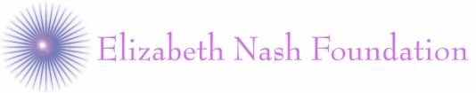



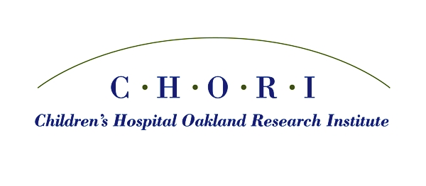

**2020 CHORI Summer Research Program**

Elizabeth Nash Foundation Cystic Fibrosis SUMMER

RESEARCH AWard

Application deadline: **April 17, 2020 by 4:00 pm PST**

Award announcement: **April 24, 2020 by E-mail**

**Objective**

The objective of the Elizabeth Nash Foundation Cystic Fibrosis Summer Research Award is to provide short-term research training opportunities in the specific area of Cystic Fibrosis at the UCSF Benioff Children’s Hospital Oakland and the Children’s Hospital Oakland Research Institute. The program is open to high school seniors and undergraduate students. The goal is to identify students who have a strong interest in pursuing research in Cystic Fibrosis. The program provides the students with a research training experience to stimulate interest in biomedical and/or clinical research in a friendly and nurturing environment.

The awardee will be paired with a scientist involved in cystic fibrosis research who will guide them through their research projects. The program is based on a structured curriculum, including participation in weekly seminars and a one-day Research Symposium.

**Funding**

The awardee will be provided a one-time stipend of $4,000 for the 9-week period.

Out of state students may be eligible for a travel/housing stipend of $1,000.

**Duration**

June 8, 2020 to August 7, 2020

**To qualify:**

* The candidate should have a strong interest and commitment to research in cystic fibrosis with a good academic standing
* The applicant should be a High School senior going into College/University or an Undergraduate student
* Students from families or with friends affected by cystic fibrosis are encouraged to apply. Students must be citizens or non-citizen nationals of the United States, or must have been lawfully admitted for permanent residency (i.e., in possession of the Alien Registration Receipt Card I-551 or I-151) at the time of appointment. Individuals on temporary or student visas are not eligible.

**Selection of Candidates**

A selection committee will meet and review all applications. Criteria for selection of the candidate will include commitment to research in cystic fibrosis, potential, enthusiasm, career goals and ability (based on the written essay and demonstrated by courses taken, grades, and letters of recommendation). The selected student will be notified via e-mail.

**2020 CHORI SUMMER RESEARCH PROGRAM**

**CURRICULUM**

**Student Orientation, June 8, 2020**

There will be a program orientation for interns on Monday, June 8,2020 from 9:00 am - 4:00 pm. (required for all students). Agenda to include:

* Introduction and overview by Director and Co-Directors
* Keynote lecture
* Explanation of curriculum
* CHORI tour and badges

**Safety Training, June 9, 2020**

For all students who will be working with mentors in a basic science laboratory, a mandatory Safety Training with CHORI Safety Officer, Miriam Fang. Students are required to complete this training BEFORE beginning their laboratory projects. 

**Student Enrichment, June 15, 2020**

There will be a half-day community building event for summer interns on Monday, June 15,2020 (required for all students), 9:00 – 1:00 pm

**Research Project: June 8, 2020 to August 7, 2020**

The student will conduct research with the assigned mentor. The details of project and research plan are left entirely to the individual mentor and each summer intern will follow the procedures, and schedule, laid out by their respective labs.

**Submit Written Research Plan: June 24, 2020 (due by 4:00 PM)**

Students must submit to the Program Coordinator a written Research Plan outlining their project. The Research Plan should be 3 pages long and include:

1. Statement of hypothesis
2. Specific aims
3. Background
4. Methods
5. Anticipated outcome of project

Students will work closely with their mentor in the preparation of these reports, and mentors should review and approve the reports before submission. Figures, flow charts and schematics may be used to illustrate the research plan. The written report will be sent to: [ssrp@chori.org](mailto:ssrp@chori.org), and must include student’s name, mentor’s name and the title of the project.

**Submit Research Abstract: July 15, 2020 (due by 4:00 P.M)**

Students will work closely with their mentors in the preparation of abstracts concisely summarizing their work. A committee comprised of the Director, Co-Directors and other leading members of the CHORI scientific community will review the abstracts for the Symposium. Abstracts will be considered for either presentation in an oral format or as a poster.

##### Weekly Lectures: Current Topics in Health and Disease

##### Students are required to attend weekly lectures every Thursday afternoon during the program delivered by CHORI, BCHO, UCB and UCSF faculty members. The lectures will cover various scientific topics, as well as discussions regarding women’s and minority’s issues, career planning, how to read and review literature, scientific ethics and Responsible Conduct of Research.

**Student Photo Day: June 15, 2020**

All students must be present.

**2020 CHORI Summer Student Symposium: August 7, 2020**

A one-day symposium will be held on Friday, August 7, 2020 where all students are **required** to participate. The students will submit an abstract concisely summarizing their work, which will be considered for an oral or a poster session for the Symposium. The Symposium will be comprised of oral presentations (10 minutes each, with 5 minute discussion), and a poster session during which the presenters will be on-hand to explain their research project. A catered breakfast and lunch will be provided for all attendees on the Symposium day.

A certificate of participation in the CHORI Summer Student Research Program will be awarded to those who successfully complete the program.

**Summary of important dates:**

June 8, 2020        Program Orientation: 9:00 A.M. – 4:00 P.M. (required for all students)

June 9, 2020 Safety Training: (mandatory)

June 15, 2020 Student Enrichment: 9:00 A.M. – 1:00 P.M. (required for all students)

June 15, 2020            Student Photo Day: All Students must be present

June 16, 2020            Safety Training: Make-up

June 24, 2020            Written Research Plan due by 4:00 P.M.

July 1, 2020            Personal Statement for Program Guide due by 4:00 P.M.

July 15, 2020         Research Abstract due by 4:00 P.M.

August 7, 2020     Summer Student Research Symposium: All Day (required for all students)

**Please e-mail any additional questions and concerns to:** [ssrp@chori.org](mailto:ssrp@chori.org)